Welcome to A R Textiles Ltd

A R Textiles ltd, has one of the most modern, state of the art Textile mills in the world. The plant is located in Robersonville NC, USA. The proximity to the cotton fields and the port of Norfolk enables AR to supply high quality yarn throughout the world.. Customers benefit from the automated processes with minimal manual intervention in the process. The automated packaging system, delivering large package sizes, combined with Digi winding make it especially attractive to the market.

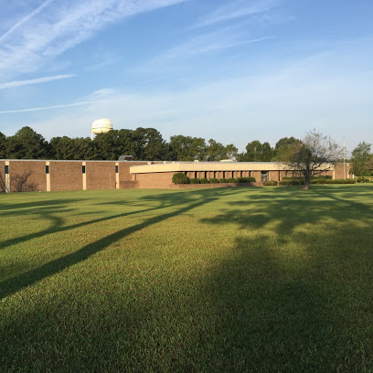

About Us

The plant has a capacity to produce 2.6 million lbs (12,000 tonnes) of high quality yarn per annum, with a count range between 6-30s Ne with the state-of-the-art technology from the leading Textile Machinery manufactures like Schlafhorst, Trutzschler Electrojet and Pneumafil. The complete textile laboratory is from Uster Switzerland.

The current market demand for contamination free, quality yarn is achieved by using quality US grown cotton, selected after testing in the laboratory for staple length, micronaire, tenacity, trash content and contamination. The latest generation of opening from Trutzschler and spinning using the Saurer ACO 8, ensures the highest quality of yarn.

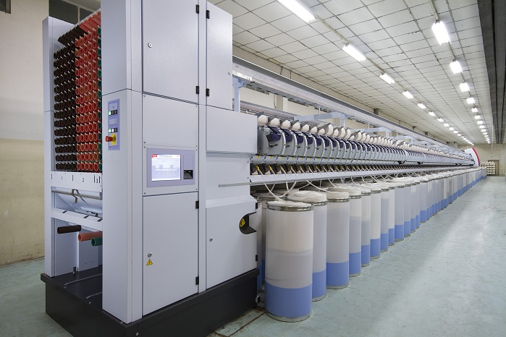

Products

**Yarn**

100% Cotton Open end single yarn

Sample yarn for weaving and knitting

Counts range NE 6-30 /1 for Carded knitting and weaving

**Services**

Samples and technical specifications of all products

Regular and prompt correspondence/communication

Frequent visits to all our valued customers for personal interaction and better understanding.

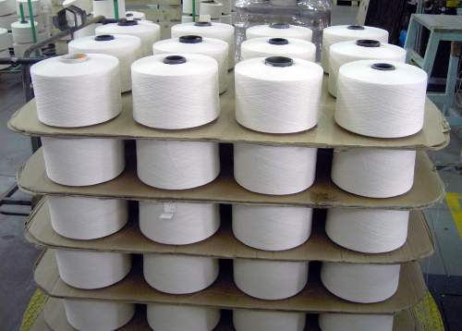

QUALITY ASSURANCE

We are equipped with the latest testing equipment to monitor and maintain a high-quality product from raw cotton to finished yarn. Our process specialists and technicians closely monitor every stage of production using the state-of-the-art Uster laboratory tools. Uster statistics make a major contribution because the Uster testing instruments automatically rate the tested yarn quality against Uster statistics.

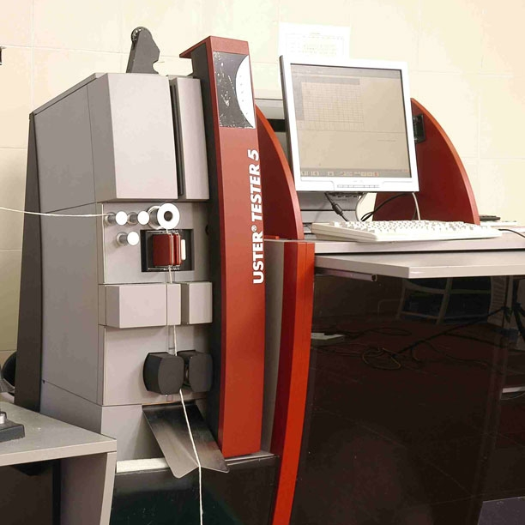

Contact

A R Textiles Ltd

8902., US Hwy 64 Alt W

Robersonville, NC

27871, USA.

Office:     (252) 795-0285

Fax:          (252) 795-0288

https://www.google.ca/maps/place/8902+U.S.+64+Alternate,+Robersonville,+NC+27871,+USA/@35.8259265,-77.2065925,13.5z/data=!4m5!3m4!1s0x89aefdefa3f83a7f:0x8f0684640943e66!8m2!3d35.824491!4d-77.208498